Grid Documentation

Contents

Configuration of the grid: 3

Grid Configuration Properties: 3

Note: Accept array of objects only 3

Stretched goals: 3

1. Use JSDoc writer for API documentation: 3

2. Pivot- Unpivot 3

3. Editable: 3

Project structure: 3

Js 3

Vendor modules 3

Grid modules 3

Utilities 3

Template 3

Css 3

Img 3

Basic Grid configuration (excerpts from various libraries): 3

1. Create basic grid with below data and configuration: 3

2. Column configuration: 3

3. Stacked column headers: 3

4. Format cell data: 3

a. Define various formatters possible 5

5. Get-set table data: 5

6. Use specific model for data table using recordType configuration: 5

7. Get remote data: 5

8. Format to specify basic grid creation steps: 5

9. Table inline messages: 5

a. Loading image 5

b. No data 5

c. Error message 5

10. Render table to given html element and column width configuration: 5

11. Column sorting: 5

a. Set all columns sortable: 5

b. Set specific columns sortable: 5

c. Custom sorting: 5

d. Sort methods: 5

12. Table mutation i.e. Add/ delete/ modify column/ row: 5

a. Column mutation: 5

b. Row mutation: 5

13. TODO: Update for scrolling table and other pending features 5

# Configuration of the grid:

1. Data: to hold the current shown data for grid
2. ServerData: hold data from server
3. Filterable
   1. Columns
   2. Filter criteria
   3. Check filter on ***Excel*** for more details
4. Scrollable
5. Pageable
   1. Input
   2. First and last
   3. Next and previous
   4. Page numbers
6. Expandable

# Grid Configuration Properties:

|  |  |
| --- | --- |
| **Required** | **Optional** |
| 1. Data source 2. Column configuration    1. Column names    2. Column label    3. Column index    4. Column sortable       1. Column sort type    5. Column align 3. Row options 4. Sort Column 5. Sort order 6. Server/ Client side load 7. Caption | 1. Current row count(#) |

### Note: Accept array of objects only

# Stretched goals:

### Use JSDoc writer for API documentation:

### Pivot- Unpivot

### Editable:

#### Add records and update to DB/ Data source

# Project structure:

## Js

### Vendor modules

#### Require

#### Knockout

#### JQuery

#### Bootstrap

### Grid modules

#### Grid

#### Grid Column Formatter

#### Grid Data Handler

#### Grid Drill down

#### Grid Pagination

#### Grid Sort

#### Grid utility

### Utilities

### Template

## Css

#### Bootstrap

#### Bootstrap.min

#### Bootstrap-responsive

#### Bootstrap-responsive.min

#### Grid

## Img

# Basic Grid configuration (excerpts from various libraries):

## Create basic grid with below data and configuration:

|  |
| --- |
|  |
| **Output:** |

## Column configuration:

|  |
| --- |
|  |
| **Output:** |

## Stacked column headers:

|  |
| --- |
|  |
| **Output:** |

## Format cell data:

|  |
| --- |
|  |
|  |
| **Output:** |

### Define various formatters possible

|  |
| --- |
|  |

## Get-set table data:

|  |
| --- |
|  |

## Use specific model for data table using recordType configuration:

|  |
| --- |
|  |

## Get remote data:

|  |
| --- |
|  |

## Format to specify basic grid creation steps:

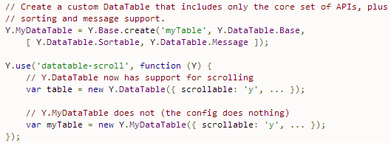

## Table inline messages:

### Loading image

### No data

### Error message

## Render table to given html element and column width configuration:

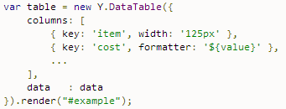

## Column sorting:

### Set all columns sortable:

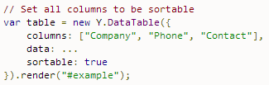

### Set specific columns sortable:

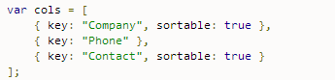

### Custom sorting:

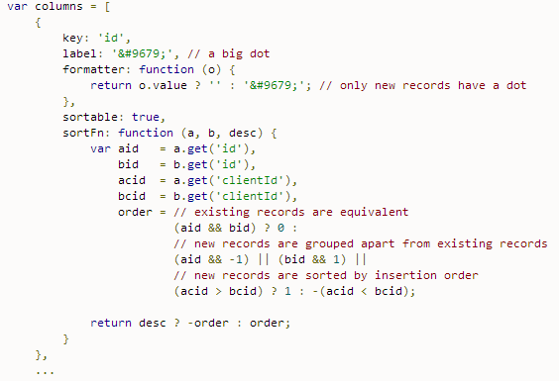

### Sort methods:

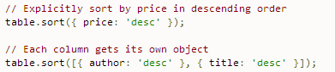

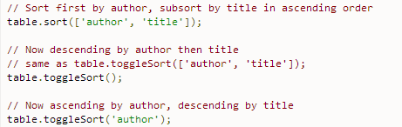

## Table mutation i.e. Add/ delete/ modify column/ row:

### Column mutation:

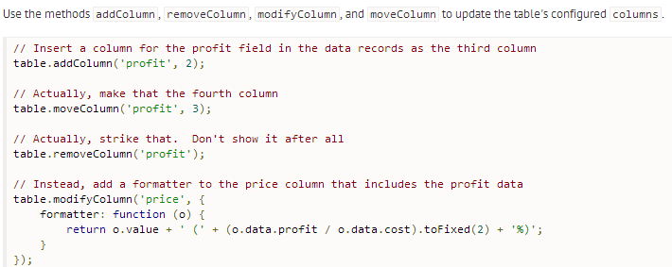

### Row mutation:

|  |
| --- |
| **Tell server to update:** |

## TODO: Update for scrolling table and other pending features